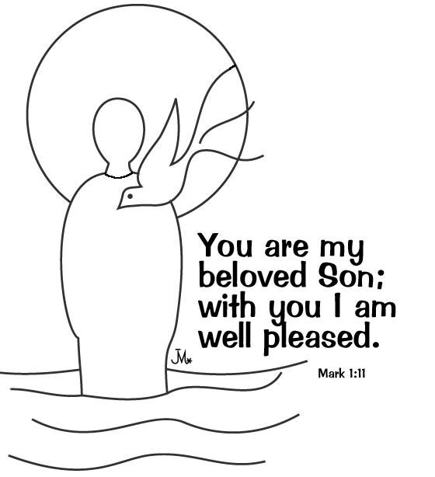

**So, what is so new about a New Year?**

I once heard an interview on Radio Nottingham with a lady who had just turned 106. The reporter (as you would) asked her the secret of her long life. She replied with a giggle that belied her age. ‘Well dear, you just have to have as many birthdays as you can!’ All of us can testify when we pass a ‘significant’ birthday that we actually feel no different than we did the day before. On a sunny day in May, when in full health, you can feel ten years younger than on a cough and cold ridden January day five months previous. Yet we all need what a New Year provides. It represents a symbol of starting afresh. The new diaries and multiple Calendars from Christmas are all pure ‘white space’ ready to be filled with new adventures (good and bad). For Christians the church year also provides us with shape, structure and rhythm. The first Sunday in January is appropriately focussed on the Baptism of Jesus which marked for him the start of a new phase in his ministry. Even John asked him ‘do you need to be baptised’ i.e. no sins to symbolically wash away and no baptism of repentance required. Jesus replied; ‘It is fitting’, literally ‘it is timely’. It was a pivotal focus moment. Does 2018 contain such moments for us? We will find our but let us, like Jesus, begin the new phase of our ministry that is 2018.

**January 2018**

Welcome to St Peter’s Church, Tollerton. Our Sunday

Services begin at 10am. Joint Sunday services

at the Methodist Church begin at 10.30am. Please

stay for coffee, tea or juice after the service.

|  |  |
| --- | --- |
| **7th**  **14th** | **HOLY COMMUNION**  **MORNING WORSHIP** |
|  |  |
| **21st**  **28th**  **4th Feb** | **HOLY COMMUNION**  **At Methodist Church**  **Covenant Service**  **Holy Communion**  **Rev Mike Payne** |

lf you know of anyone who needs a lift to church

or who is unwell or would like a visit please let

Ruth (937 6968) or Norma (937 3814) know.

**Church Website:** [www.stpeters-tollerton.org.uk](http://www.stpeters-tollerton.org.uk)

ST. PETER’S CHURCH, TOLLERTON

Rector: Rev Canon Alan Howe (937 2349)

Churchwardens: Ruth Hartley (937 6968)

Norma Smith (937 3814)

