Welcome to St Peter’s Church, Tollerton. Services begin at 10am unless other times given.
2nd  9th  16th  23rd  30th | June 2019  MORNING WORSHIP  Acts 16 16-34; John 17 20-end  PENTECOST HOLY COMMUNION  Acts 2 1-21; John 14 8-17  TRINITY SUNDAY MORNING WORSHIP  Romans 5 1-5; John 16 12-15  HOLY COMMUNION  Gal 3 23-end; Luke 8 26-39  CHURCHES TOGETHER at  TOLLERTON METHODIST CHURCH 10.30  lf you know of anyone who needs a lift to church or who is unwell or would like a visit please let Ruth (937 6968) or Norma (937 3814) know.  Church Website: www.stpeters-tollerton.org.uk

ST. PETER’S CHURCH, TOLLERTON
Rector: Rev Canon Alan Howe (937 2349)
Churchwardens: Ruth Hartley (937 6968)
Norma Smith (937 3814)

H

Yours in Christ Alan

Please spread the word about our concert on July 7

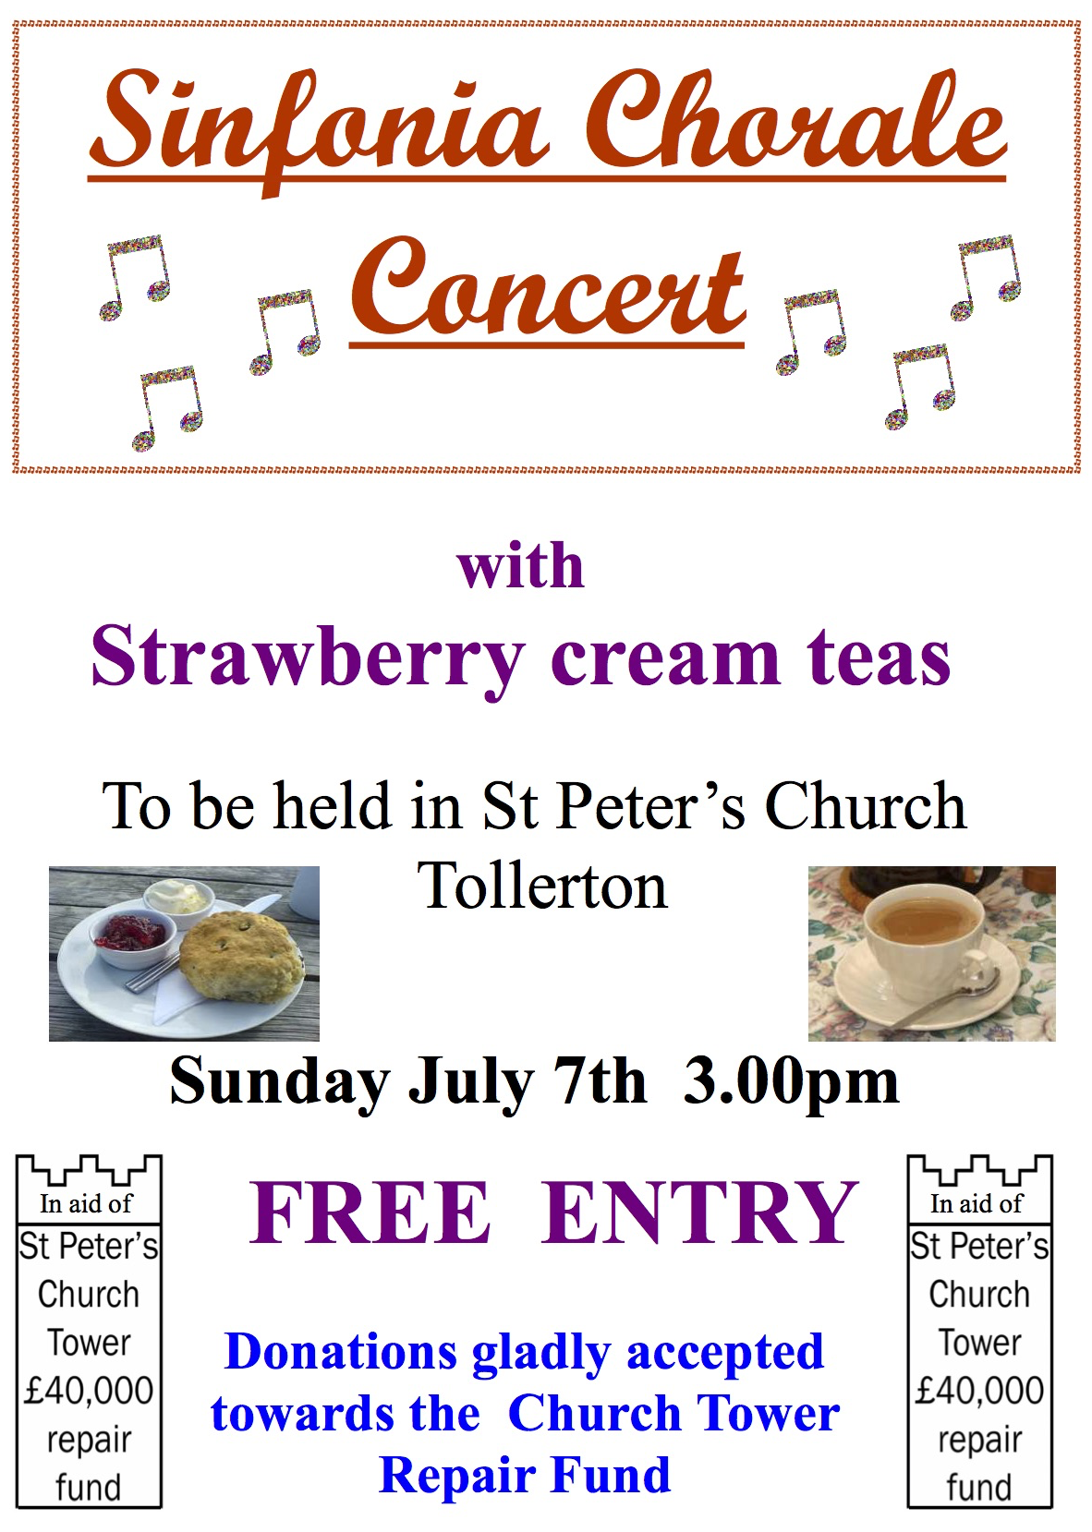


ST. PETER’S CHURCH, TOLLERTON
Rector: Rev Canon Alan Howe (937 2349)
Churchwardens: Ruth Hartley (937 6968)
Norma Smith (937 3814

