**October 2018**

Welcome to St Peter’s Church, Tollerton. Our Sunday

Services begin at 10am. Joint Sunday services

at the Methodist Church begin at 10.30am. Please

stay for refreshments after the service.

|  |  |
| --- | --- |
| **7th**  **14th** | **HOLY COMMUNION**  **MORNING WORSHIP** |
| **21st**  **28th** | **HOLY COMMUNION with Methodist**  **Church at St Peter’s**    **MORNING WORSHIP** |
| **Nov 4th** | **HOLY COMMUNION** |

lf you know of anyone who needs a lift to church

or who is unwell or would like a visit please let

Ruth (937 6968) or Norma (937 3814) know.

**Church Website:** [www.stpeters-tollerton.org.uk](http://www.stpeters-tollerton.org.uk)

H

**Pat tests out Ride and Stride tandem**

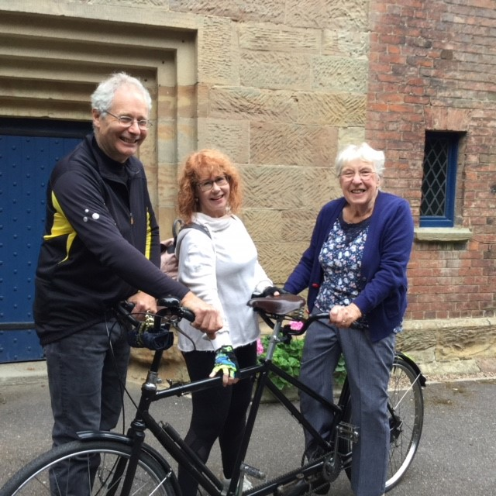

Church organist Derek Langdon of Edwalton and his sister Susie of Nottingham were the first visitors to St Peter’s on last month’s Ride and Stride Saturday. Before they left to continue their Ride around the historic churches of South Notts and the Vale of Belvoir they got Pat to try out Derek’s pre-Second World War tandem.

Meanwhile Alan successfully completed his Stride from St Peter’s to Nottingham City Centre, visiting seven churches en route and raising £200 which will be divided between Nottinghamshire Historic Churches Trust and St Peter’s. Congratulations Alan.

Yours in Christ ***Alan***

ST. PETER’S CHURCH, TOLLERTON

Rector: Rev Canon Alan Howe (937 2349)

Churchwardens: Ruth Hartley (937 6968)

Norma Smith (937 3814)

