Welcome to St Peter’s Church, Tollerton. Services begin at 10am unless other times given.

|  |  |
| --- | --- |
| **6th**  **13th** | **January 2019**  **HOLY COMMUNION**  Epiphany  **MORNING WORHIP**  Baptism of Christ |
| **20th**  **27th**  **3rd**  **Feb** | **CHURCHES TOGETHER at METHODIST**  **CHURCH COVENANT SERVICE 10.30AM**  **MORNING WORSHIP**  Epiphany 4  **HOLY COMMUNION**  Candlemas |

lf you know of anyone who needs a lift to church

or who is unwell or would like a visit please let

Ruth (937 6968) or Norma (937 3814) know.

**Church Website:** [www.stpeters-tollerton.org.uk](http://www.stpeters-tollerton.org.uk)

**May 2019 be a peaceful and**

**blessed New Year for**

**St Peter’s and everyone.**

**Yours in Christ, *Alan***



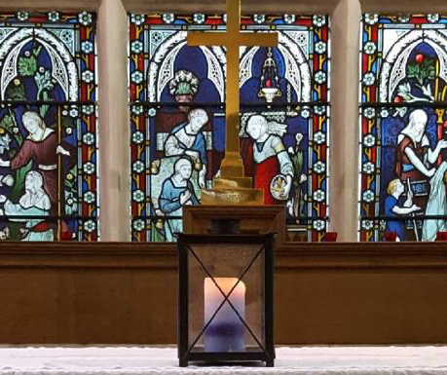

ST. PETER’S CHURCH, TOLLERTON

Rector: Rev Canon Alan Howe (937 2349)

Churchwardens: Ruth Hartley (937 6968)

Norma Smith (937 3814

 





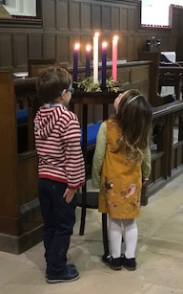

H

Yours in Christ ***Alan***

ST. PETER’S CHURCH, TOLLERTON

Rector: Rev Canon Alan Howe (937 2349)

Churchwardens: Ruth Hartley (937 6968)

Norma Smith (937 3814)