**December 2018**



Welcome to St Peter’s Church, Tollerton. Services begin at 10am unless other times given.

|  |  |
| --- | --- |
| **2nd**  **9th** | **HOLY COMMUNION**  **MORNING WORHIP** |
| **16th**  **23rd**  **24th** | **HOLY COMMUNION**  **6.30pm CAROLS BY CANDLELIGHT**    **MORNING WORSHIP**  **4pm CHRISTMAS EVE CHRISTINGLE** |
| **25th**  **30th** | **CHRISTMAS DAY HOLY COMMUNION**  **CHURCHES TOGETHER HOLY COMMUNION**  **At St Peter’s** |

lf you know of anyone who needs a lift to church

or who is unwell or would like a visit please let

Ruth (937 6968) or Norma (937 3814) know.

**Church Website:** [www.stpeters-tollerton.org.uk](http://www.stpeters-tollerton.org.uk)

H

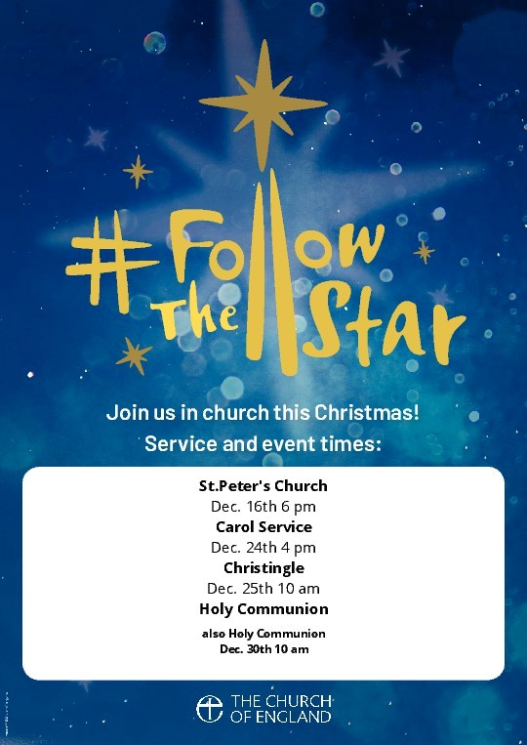

***We wish you a very happy, peaceful***

***and blessed Christmas***

Yours in Christ ***Alan***

ST. PETER’S CHURCH, TOLLERTON

Rector: Rev Canon Alan Howe (937 2349)

Churchwardens: Ruth Hartley (937 6968)

Norma Smith (937 3814)

